Chapter 11 Exam Review Name _________________________________

Given the points: *X* (9, 22) and *Y*(-7, 2), find:

1. *XY* = 2. The midpoint of 

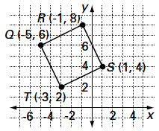3. *QRST* is located on the coordinate plane at the right*.*

a. Prove *QRST* is a rhombus.

b. Show that its diagonals bisect each other.

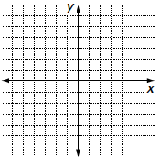

4. On the coordinate axes at the right, draw a kite in a   
 convenient location and label its vertices with appropriate

coordinates.

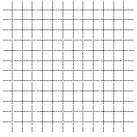5. Consider the circle with center (-3, 6) and radius 5.

a. Give an equation for this circle.

b. Graph the circle at the right.

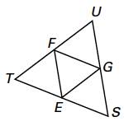6. ∆*STU* has midpoints at *E, F,* and *G.*

a. Explain why  .

b. If *SE* = 8.2 cm, find *FG*.

ANSWERS

|  |  |
| --- | --- |
| 1.  2. (1, 12)  3a.    Because *RT* = *RS* = *ST* =  *QT, QRST* is a rhombus.  3b. Midpoint of  =  = (-2, 5);  Midpoint of  =  = (-2, 5)  Since the midpoints of  and  are the  same,  and  bisect each other. | 4. (sample) 5b.  Macintosh HD:Users:lisahoneyman:Desktop:Screen shot 2014-06-04 at 11.16.29 PM.png  Macintosh HD:Users:lisahoneyman:Desktop:Screen shot 2014-06-04 at 11.17.45 PM.png  5a. (x + 3)2 + (y – 6)2 = 25  6a. Since F and G are midpoints,  is  parallel to .    6b. 8.2 cm. |