Name: _________________________________ Date: ___________
Chapter 9 and 11 Review

1. Determine if the following functions represent exponential growth, decay or neither.
a. 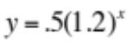 | b. 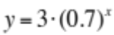 | c. 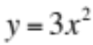
d. 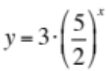 | e. 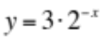 | f. 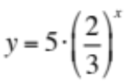

2. Consider the function: 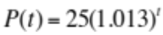

a. Does this model exponential growth, exponential decay, or neither? ______________________

b. What is the domain of this function? ___________________________________________

c. What is the range of this function? ___________________________________________

d. What is the y-intercept of this function? ______________________________________

e. In which quadrant does the curve approach the horizontal axis? ____________________

3. For the following rates of growth and decay, find the multiplier (b) that should be used in the equation.

a) 2.5% growth _______________ b) 3% decay ________________ c) 10% decay _______________

4. A start-up company has sales of $10,000 during its first year. Suppose that sales increase at a rate of 12% per year. Write an exponential equation to model this situation. Then predict how much the company will make after 5 years.

5. A house is purchased for $500,000 in 2013. The value of the house is known to increase exponentially at a rate of 4.5% per year. Write an exponential equation to model this situation. Then predict how much the property will be worth in 2020 if this rate of growth continues.

6. One of the radioactive elements in a nuclear meltdown has a half-life of 50 years. Until the element decays completely (or to some small pre-determined level), the site is contaminated. Suppose there are 100 grams of element to start. How many grams will there be after 200 years?

7. Given the polynomial 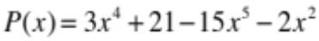, identify the following:
a) Write in standard form: | b) Degree:
c) Leading coefficient: | d) Constant term:
e) P(1) = | f) P(-2) =

8. First identify whether each is a polynomial, then fill out the chart for those that are polynomials. [Do not fill out the chart for those that are not polynomials.]
Put in Standard Form  if Needed | Polynomial?  Yes or No | Classify by Degree | Classify by Number  of Terms | Leading Coefficient
a. 7x³ – 2x³

b. 12x²y + 7x³y⁴

c. 3x⁻³ + 5

d. 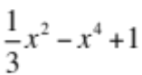

e. 8^{x} – 5x

f. 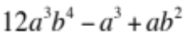

9. Expand (multiply) and simplify:
a) 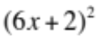 | b) 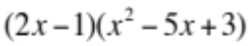

10. a) Find the zeros (roots) of each polynomial equation or function, including multiplicities.
b) Tell whether the zeros are real (rational or irrational) or complex.
a. 7x(x - 5)(4x - 9) = 0 | b. 6x³(x + 3)⁴(5x – 4) = 0
c. 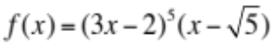 | d. 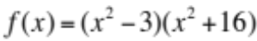

11. Factor the following completely using any method we discussed in class. {1. GCF, 2. Special Cases, 3. Guess and Check, 4. Quadratic Formula} [Make sure all equations are set equal to 0 first, if necessary.]

a. 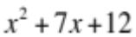 | b. 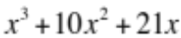
c. 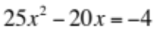 | d. 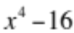
e. 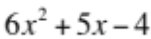 | f. 6x³y⁵ + 9x²y³
g. 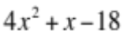 | h. 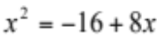

12. Solve for the zeros (roots) by factoring. (Make sure to set everything equal to 0 first).
a. 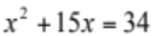 | b. 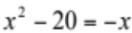
c. 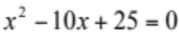 | d. 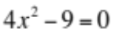
e. 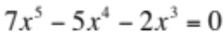 | f. 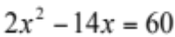

13. Write two different polynomials functions whose zeros are 8, -2 and - .

14. Write two different polynomials functions whose zeros are -12, 0, 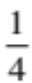 and -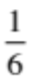.

15. Find an equation for a quadratic function whose graph crosses the x-axis at (-5, 0) and (4, 0).

16. How many total roots does each polynomial function have? (Fundamental Theorem)
a. 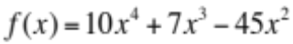 | b. 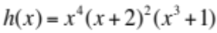
c. 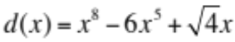 | d. 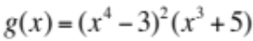
17. Use the method of Finite Differences to determine the degree of the polynomial that produces the sequence of numbers.

x | 1 | 2 | 3 | 4 | 5 | 6 | 7 | 8
y | 10 | 31 | 88 | 199 | 382 | 655 | 1036 | 1543

18. Is the function that models the data a polynomial function? If yes, state the degree. If not, explain why not.
a.
x | 1 | 2 | 3 | 4 | 5 | 6
y | 7 | 12 | 18 | 25 | 33 | 42

b.
x | 1 | 2 | 3 | 4 | 5 | 6
y | 1 | 3 | 7 | 15 | 31 | 63

19. Use the method of Finite Differences to find a polynomial function that models the data.

x | 1 | 2 | 3 | 4 | 5 | 6
y | 7 | 12 | 19 | 28 | 39 | 52

x | f(x) | diff 1 | diff 2 | 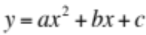 | diff 1 | diff 2
1
2
3
4
5
6

20. Use the method of Finite Differences to find a polynomial function that models the data.

x | 1 | 2 | 3 | 4 | 5
y | 4 | 6 | 6 | 4 | 0

x | f(x) | diff 1 | diff 2 |  | diff 1 | diff 2
1
2
3
4
5

ANSWERS:
1a. growth b. decay c. neither d. growth e. decay f. decay
2a. growth b. all Reals c. all positive reals 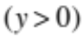 d. (0, 25) e. II
3a. 1.025 b. 0.97 c. 0.90 4. 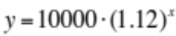 $17623.42
5. 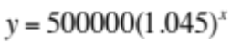 $680,430.92 6. 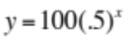 where x = # of 50 year periods, so
x = 4 and the answer is 6.25 grams
7a. 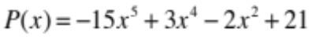 b. 5 c. -15 d. 21 e. 7 f. 541

8a. Yes; 3; monomial; 5 8b. yes; 7; binomial; 7 8c. no
8d. yes; 4; trinomial; -1 8e. no 8f. yes ; 7; trinomial; 12
9a. 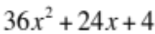 9b. 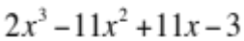 10a. 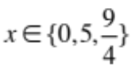 all Real, Rational roots with multiplicity of 1
10b. 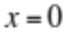 multiplicity 3, x = -3 mult. 4, x = 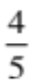 multiplicity 1, all Real, rational roots
10c. 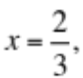 mult. 5, and 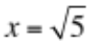, both Real. 2/3 is rational, 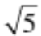 is irrational
10d. 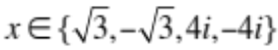; 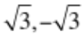 are irrational roots; 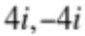 are complex roots. (all mult. 1)

11a. (x + 4)(x + 3) 11b. x(x+7)(x + 3) 11c. 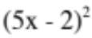 or (5x – 2)(5x – 2)
11d. 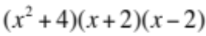 11e. (3x + 4)(2x – 1) [Use Quadratic Formula]
11f. 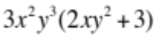 11g. (4x + 9)(x – 2) [Use Quadratic Formula] 11h. 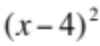

12a. (x – 2)(x + 17) = 0 so 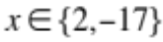 12b. (x + 5)(x – 4) = 0 so 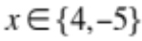
12c. 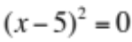 so 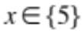 12d. (2x + 3)(2x – 3) = 0 so 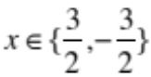
12e. 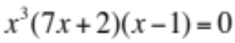 so 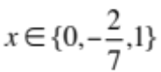 12f. 2(x + 3)(x -10) = 0 so 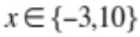

13. 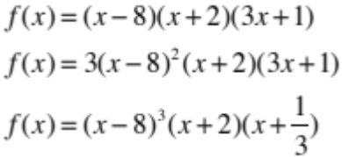 14. 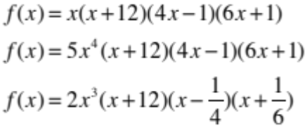
(there are many other possible answers to #13 and 14)

15. f(x) = (x + 5)(x – 4) = 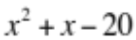; or you can multiply by any constant: f(x) = 2(x + 5)(x – 4)

16. a) 4 b) 9 c) 8 d) 11

17. degree = 3 (you should get 18 for your common difference)
18. a) Yes, degree is 2 (you should get 1 for your common difference)
b) No, the pattern repeats (2, 4, 8, 16). Each time, the differences are multiplying by 2 so it is not a polynomial function. (It is exponential instead.)
19. a = 1, b = 2, and c = 4 so the equation is 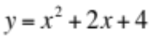
20. a = -1, b = 5, and c = 0 so the equation is

