Name: ____________________________________ Date: ________________
Chapter 8 Test Review

*** Only “mini” 5 function calculators allowed on this review packet and on the Chapter 8 TEST.
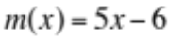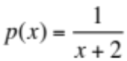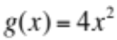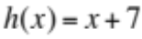
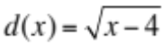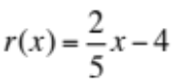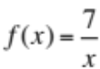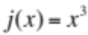

1. 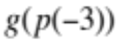 | 2. 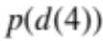
3. 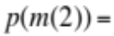 | 4. 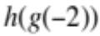
5. 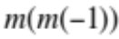 | 6. 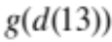
7. 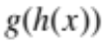 | 8. 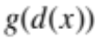
9. 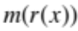 | 10. 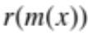
Find the domain of each of the following:
11. 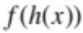 | 12. 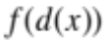
13. 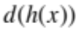 | 14.

Find the inverse:
15. 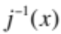 | 16. 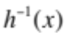
17. 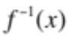 | 18. 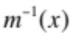
19. Are m(x) and r(x) inverses of each other? Justify your answer using one of the methods that we discussed in class (other than graphing).

Determine if each pair of functions are inverses of each other by…
20. Finding the inverse of one algebraically and comparing it to the other.
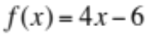
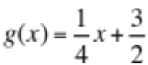

21. Verifying that 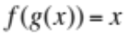 and 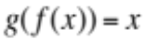
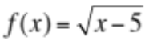
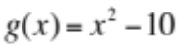

22. Let

a. What is the domain of the function f? ________________________________________________________________

b. What is the range of the function f? ________________________________________________________________

c. Find the inverse of f. ________________________________________________________________

d. What is the domain of f inverse? ________________________________________________________________

e. What is the range of f inverse? ________________________________________________________________
Use the Horizontal Line Test for Inverses to determine whether the inverse of each function is a function.
23.  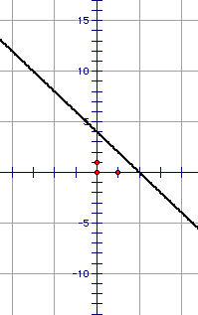  ________________________ | 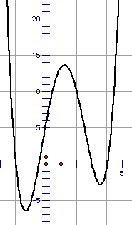  24.  _________________________ | 25.  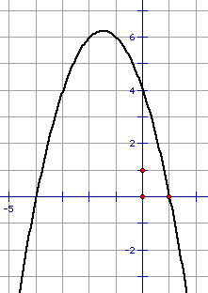  ________________________

26. Graph the inverse of the function below on the same grid.
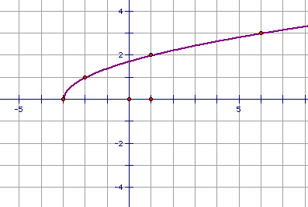

Rewrite each in exponent form
27. 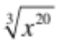 | 28. 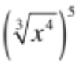 | 29.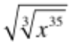

Rewrite using a single radical.
30.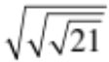 | 31. 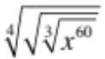 | 32. 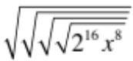

Simplify each of the following. Leave answers in the most simplified radical form.
33.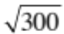 | 34.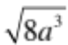
35. 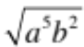 | 36. 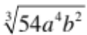
37. 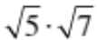 | 38. 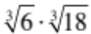
39. 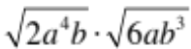 | 40. 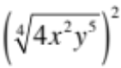
41. 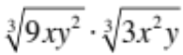 | 42.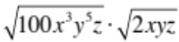
43. 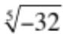 | 44. 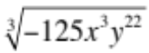

Rationalize the denominator and simplify.
45. 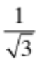 | 46. 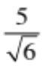
47. 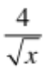 | 48. 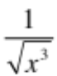
49. 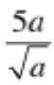 | 50. 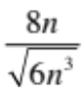
51. 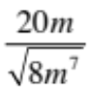 | 52. 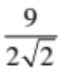
53. 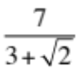 | 54. 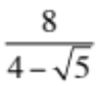
55. 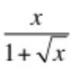 | 56. 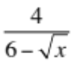
57. 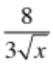 | 58. 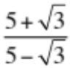
Find all real solutions to the following radical equations. Make sure to check for extraneous solutions when necessary.

59.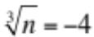 | 60. 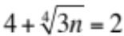
61. 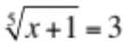 | 62. 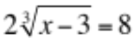
63. 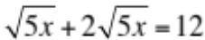 | 64. 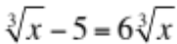
65. 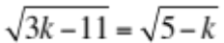 | 66. 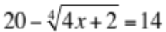
67. A sphere with radius r has a volume of 1131 cubic millimeters. The formula for the volume of a sphere is 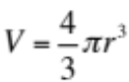. Find the length of the radius of the sphere to the nearest tenth of a millimeter.

ANSWERS:
1. 4 2.  3.  4. 23 5. -61 6. 36
7. 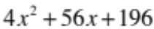 8. 4x – 16 9. 2x – 26 10. 2x – 6.4

11. All real except 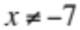. 12. x > 4 13. x ≥ -3 14. all reals

15. 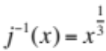 16. 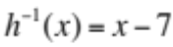 17. 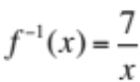 18. 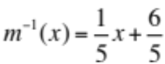

19. 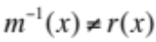 (see #18). So m(x) and r(x) are not inverses of each other.

20. 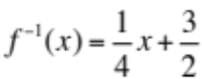. Since that is the same as g(x), f(x) and g(x) are inverses of each other.

21. 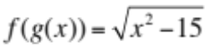. Since this is not the same as x, f(x) and g(x) are not inverses of each other.

22. a. {7, 4, 3, -1, 9} b. {5, 4, -2, 8, 0} c. {(5, 7), (4, 4,), (-2, 3), (8, -1), (0, 9)}
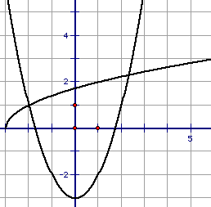
d. {5, 4, -2, 8, 0} e. {7, 4, 3, -1, 9} 26.

23. yes 24. no 25. no

27. 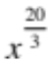 28. 29. 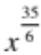

30. 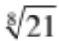 31. 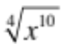 or 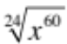

32. 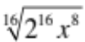 or 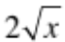 33. 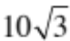 34. 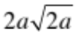

35. 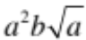 36. 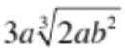 37. 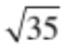 38. 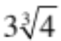 39. 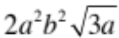

40. 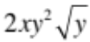 41. 3xy 42. 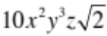 43. -2 44. 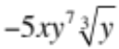

45. 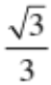 46. 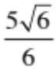 47. 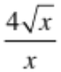 48. 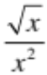 49. 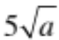

50. 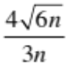 51. 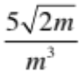 52. 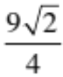 53. 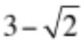 54. 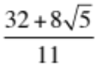
55. 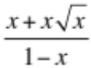 56. 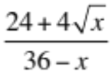 57. 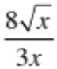 58. 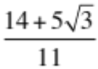 59. n = -64

60. No solution (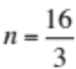is an extraneous solution) 61. x = 242 62. x = 67
63. 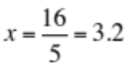 64. x = -1 65. k = 4 66. X = 323.5 67. r = 6.5 mm

