Name: _____________________________ Date: __________
Math 2(622)
MID-YEAR

Objectives
The student should be able to:

- Square a binomial expression
- Write a quadratic expression for the perimeter and area of a given rectangular real world object
- Sketch the graphs of the squaring function, absolute value function, square root function and the cubic and quartic function from memory; draw their graphs by plotting points, and identify them from their graphs
- Transform a quadratic expression written in standard form to graphing form by completing the square
- Quickly sketch the graphs of parabolas whose equations are in graphing form
- Write the coordinates of the vertex and the equation of the axis of symmetry from the equation of a parabola, say whether the curve opens up or down and whether it is congruent to 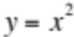
- Write the quadratic formula from memory, use it to solve any quadratic equation, write the solutions in exact form, approximate the exact solutions using your calculator (calculators may not be shared)
- Change square roots of negative numbers to form and add, subtract and multiply any two complex numbers
- Evaluate functions for given values and evaluate composition of two functions for given values
- Use the definition of a function to determine whether a particular set of ordered pairs is a function and if it is, give its domain, range and inverse; for linear functions write the equation of the inverse (in y = mx + b form) from its given equation
- Answer questions about real world situations by analyzing functions in graph form and table form; for functions written in table form, determine the degree of the function using the method of finite differences
- Simplify expressions containing exponents that are positive, negative or zero and are integral or rational using the basic definitions and properties of exponents
- Simplifying radical expressions, taking higher roots, and converting from radical to exponent form and vice versa.
- Write out several terms of geometric series from suitable given information and use the compound interest formula (which will be given) to answer real world questions about investments
- Solve simple equations involving higher integral powers, fractional powers or square roots of the variable
- State the degree of higher degree polynomials, identify their leading coefficients, evaluate them for given values and for factorable polynomials, find their zeroes by factoring
- Write an equation of a polynomial function given its zeroes and identify zeroes of functions from their graphs
- Determine the number of zeroes a polynomial function has from its equation and graph, find all integer zeroes from the graph and then express the function in factored form
19. Exponential growth and decay

Name: ______________________________

622 Midyear Exam Review Worksheet #1 (Covers topics 1 – 6 from the midyear objectives list)

Topic #1 Squaring a binomial
1. Expand 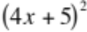 | 2. Expand 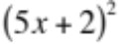
3. Expand 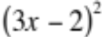

Topic #2 Perimeter and Area of a rectangular object
4. A yard is to be built with a gravel walkway around it. Suppose the yard is 100 yards by 75 yards, and you want
to make the walkway x yards wide. Give the algebraic expression in expanded form for the total area of the
yard and the walkway. {First draw a picture to help you.}

Topic #3 Squaring, taking absolute values, taking square roots, sketching graphs, velocity, acceleration
5. Simplify 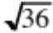 | 6. Simplify 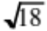 | 7. 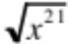=

8. Solve and make sure to find ALL solutions.
a. 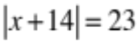 | b. 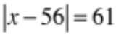 | c. Evaluate 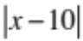 when x = -3

9. A tennis ball is hit upwards from a height of three feet off the ground with an initial velocity of 64 feet per second. The general formula for the height of an object at time t is height = 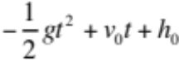.
a. What is the particular formula for the height of the ball?

b. What is the height of the ball at 2 seconds? 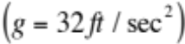

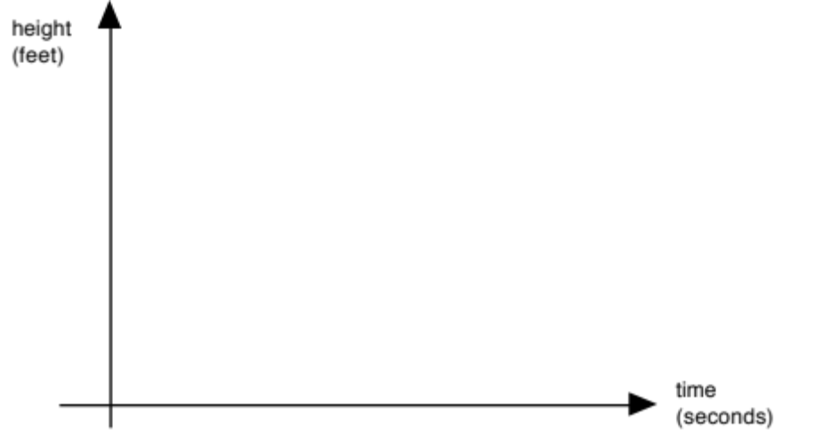
c. Sketch the graph of the ball over time.

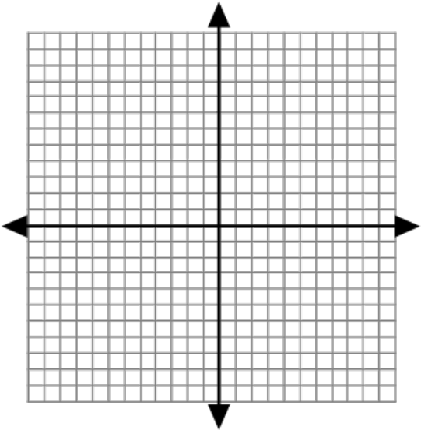
10. Sketch the graph of 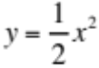
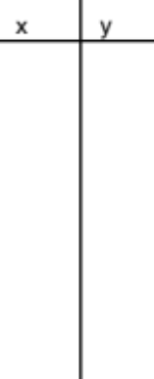

Topic 4: Completing the square
11. Transform 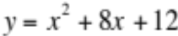 into vertex form by completing the square and state the vertex.

12. Transform y = x² – 12x – 11 into vertex form by completing the square and state the vertex.

Topic 5: Sketching graphs of parabolas whose equations are in vertex form
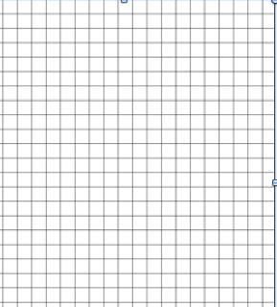
13. Graph the parabola 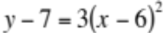

14. Graph 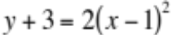

Topic 6: Determine the coordinates of the vertex and the equation of the axis of symmetry from the equation of the parabola, whether it opens up or down, and whether it is congruent to .
15.
a) What are the coordinates of the vertex for the parabola represented by the equation 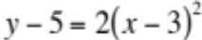?

b) What is the equation of the axis of symmetry for the parabola in part a?

c) Does the graph open up or down? _______ How do you know?

d) Is the curve congruent to the graph of ?

e) Is the graph congruent to the graph of 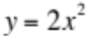?

16. Suppose the graph of were translated 5 units to the right and four units up. What is the equation of
the new parabola?

Math 622 Name _________________________
Mid-year Review Worksheet #2 (Covering Topics 7-12)

Topic 7: Writing the quadratic formula from memory and using it to solve quadratic equations

1. Write the quadratic formula from memory

2. a. Solve the equation 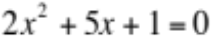using the quadratic formula.

b. Write the solution to the nearest tenth using a calculator.

Topic 8: Changing the square roots of negative numbers to form; adding, subtracting, and multiplying two complex numbers.

3. Simplify 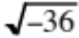.

4. Perform the operations and write the answer in 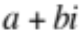 form.
a. 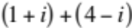 =

b. 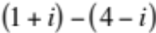 =

c. 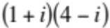 =

Topic 9: Evaluating a function for given values
5. A function is given by the formula 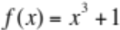

a. Find 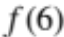

b. Find 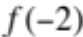

Topic 10: Determining whether a set of ordered pairs is a function; stating a function’s inverse, writing the
equation of the inverse for linear functions.
6. A function contains the following points 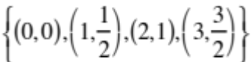

a) State the domain of the function. _______________________________________

b) State the range of the function. ________________________________________

c) State the inverse of the function. _______________________________________

7. Determine algebraically the inverse of the function 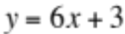 and write it in 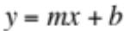 form.

Topic 11: Determine the degree of a function using finite differences; applying functions to real-life situations.

8. Find the degree of the following function.
X | 1 | 2 | 3 | 4 | 5 | 6
Y | 5 | 20 | 45 | 80 | 125 | 180

Topic 12: Simplifying expressions that contain positive, negative, zero, rational, and integral exponents.
9. Simplify the following.
a) 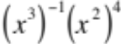 b) 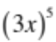 c) 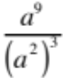

d) 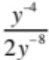 e) 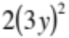 f) 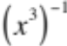

g) 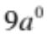 h) 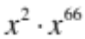 i) 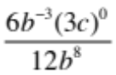

Math 622 Midyear Review Worksheet #3 (Covering topics 13-19) Name _________________________

Topic 13: Simplifying radical expressions, taking higher roots, converting from radical to exponent form & vice versa

1. Write the following in exponent form.
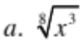 | 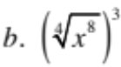

2. Write the following in radical form.
a. 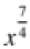 | b. 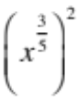

3. Simplify each radical expression.
a. 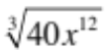 | b. 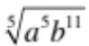 | c. 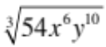

4. Simplify:
a. 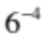 | b. 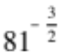
c. 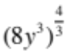 | d. 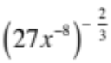
e. 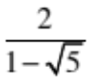 | f. 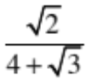

Topic 14: Writing out a geometric series from given information. Using the compound interest formula (given) to answer real world questions.

5. Write out the first six terms of the
geometric series for which =1 and . ______, ______, ______, ______, ______, ______, . . .

6. The first four terms of a geometric sequence are shown below. What is the common ratio of the sequence?
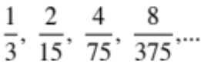
7. The compound interest formula is 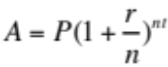. Use it to solve the following problem.
Suppose you have an account with $2000 earning 5% interest compounded semi-annually.
How much will be in our account after 20 years?

Topic 15: Solving equations with powers and square roots.

Solve each of the following equations.
8. 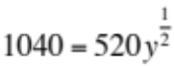 | 9. 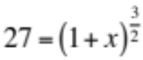
10. 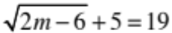 | 11. 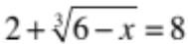

Topic 16: Stating the degree of a polynomial, identifying the leading coefficient, evaluating polynomials, finding zeroes by factoring.

12. a. What is the degree of the polynomial 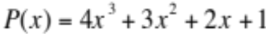? ___________

b. What is its leading coefficient? _________

c. Is the polynomial a trinomial? _________ Why or why not?

13. Find 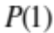 for the polynomial 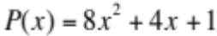. ____________
14. Factor the following:
a. 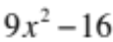 | b. 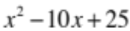

15. Find all the zeroes by factoring 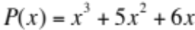.

Topic 17: Writing a polynomial function given its zeroes and identifying zeroes from graphs.
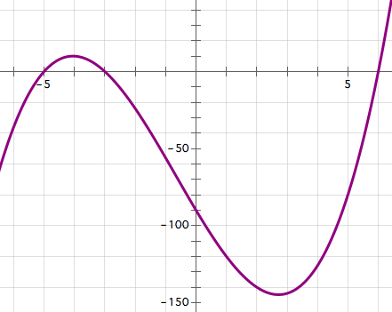
16 a. What are the zeroes of the function shown here.

b. Write a polynomial that could model this function
as a product of linear factors.

Topic 18: Determining the number of zeroes of a polynomial function from its equation and graph, and expressing it in factored form.

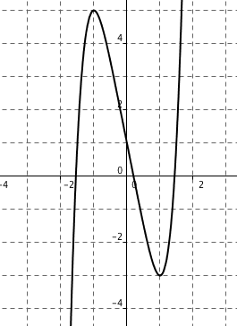
17. The graph of the function 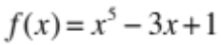 is shown here.

a. How many zeroes does the function have?

b. How many of its zeroes are real numbers?

c. How many of its zeroes are complex numbers?

18. Write an equation in factored form for the polynomial function that has zeroes 0, 2, -5.

Topic 19: Exponential growth and decay.

- Solve exactly.
a) (a + 1)⁴ = 16 | b) 7^{x} = 343

- What is the domain and range of f(x) = 2^{x}? _________________________________

- What is the y – intercept of f(x) = 2^{x}? _________________________________

- What is f(x) = 2^{x} exponential growth or decay? Explain your answer.

- In 1991 the population of the Tokyo-Yokohama region was about 27.245 million. The annual growth rate was 0.86%.
  - Write an equation in terms of t that models this situation.

  - Find the population in 2010.

- Strontium 90 has a half-life of 29 years. If you start with 5 grams, how much is left after 116 years?

- A new car costing about $13,000 is predicted to depreciate at a rate of 15% per year. About how much will the car be worth in six years? (Write an equation to model this situation.)

